Can you put NINIQ logo on top and then the bar beneath?

Top Bar:

- Update ‘Bag’ to image of bag
- Update ‘Our Story’ to ‘About’
- Update Shop Quilts —> ‘Shop’ with drop down menu
      - Digital Patterns
      - Quilts
      - Remove ‘Shopping Bag’ tab - replace with Contact/Stay Connected?
        - Add Instagram Link
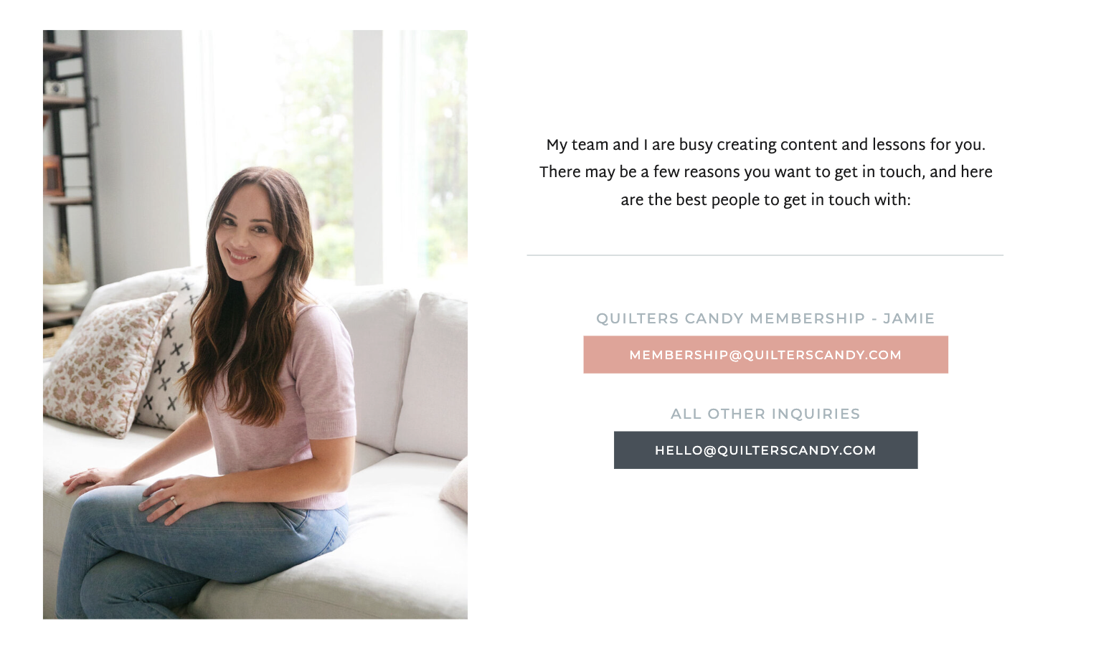
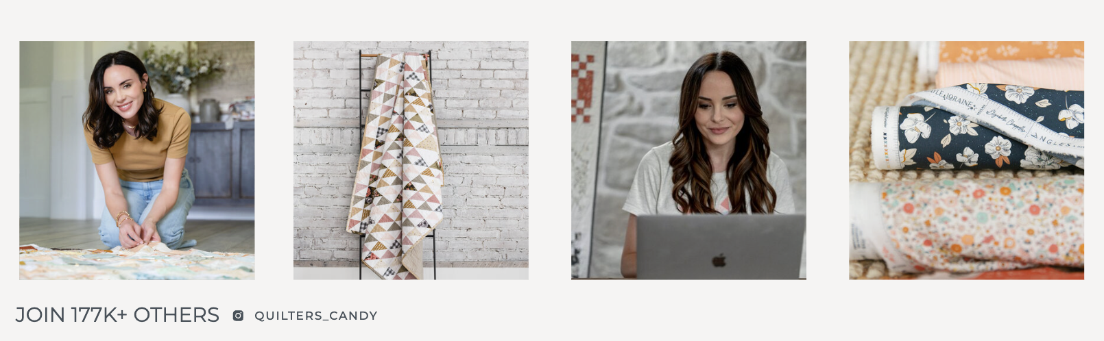
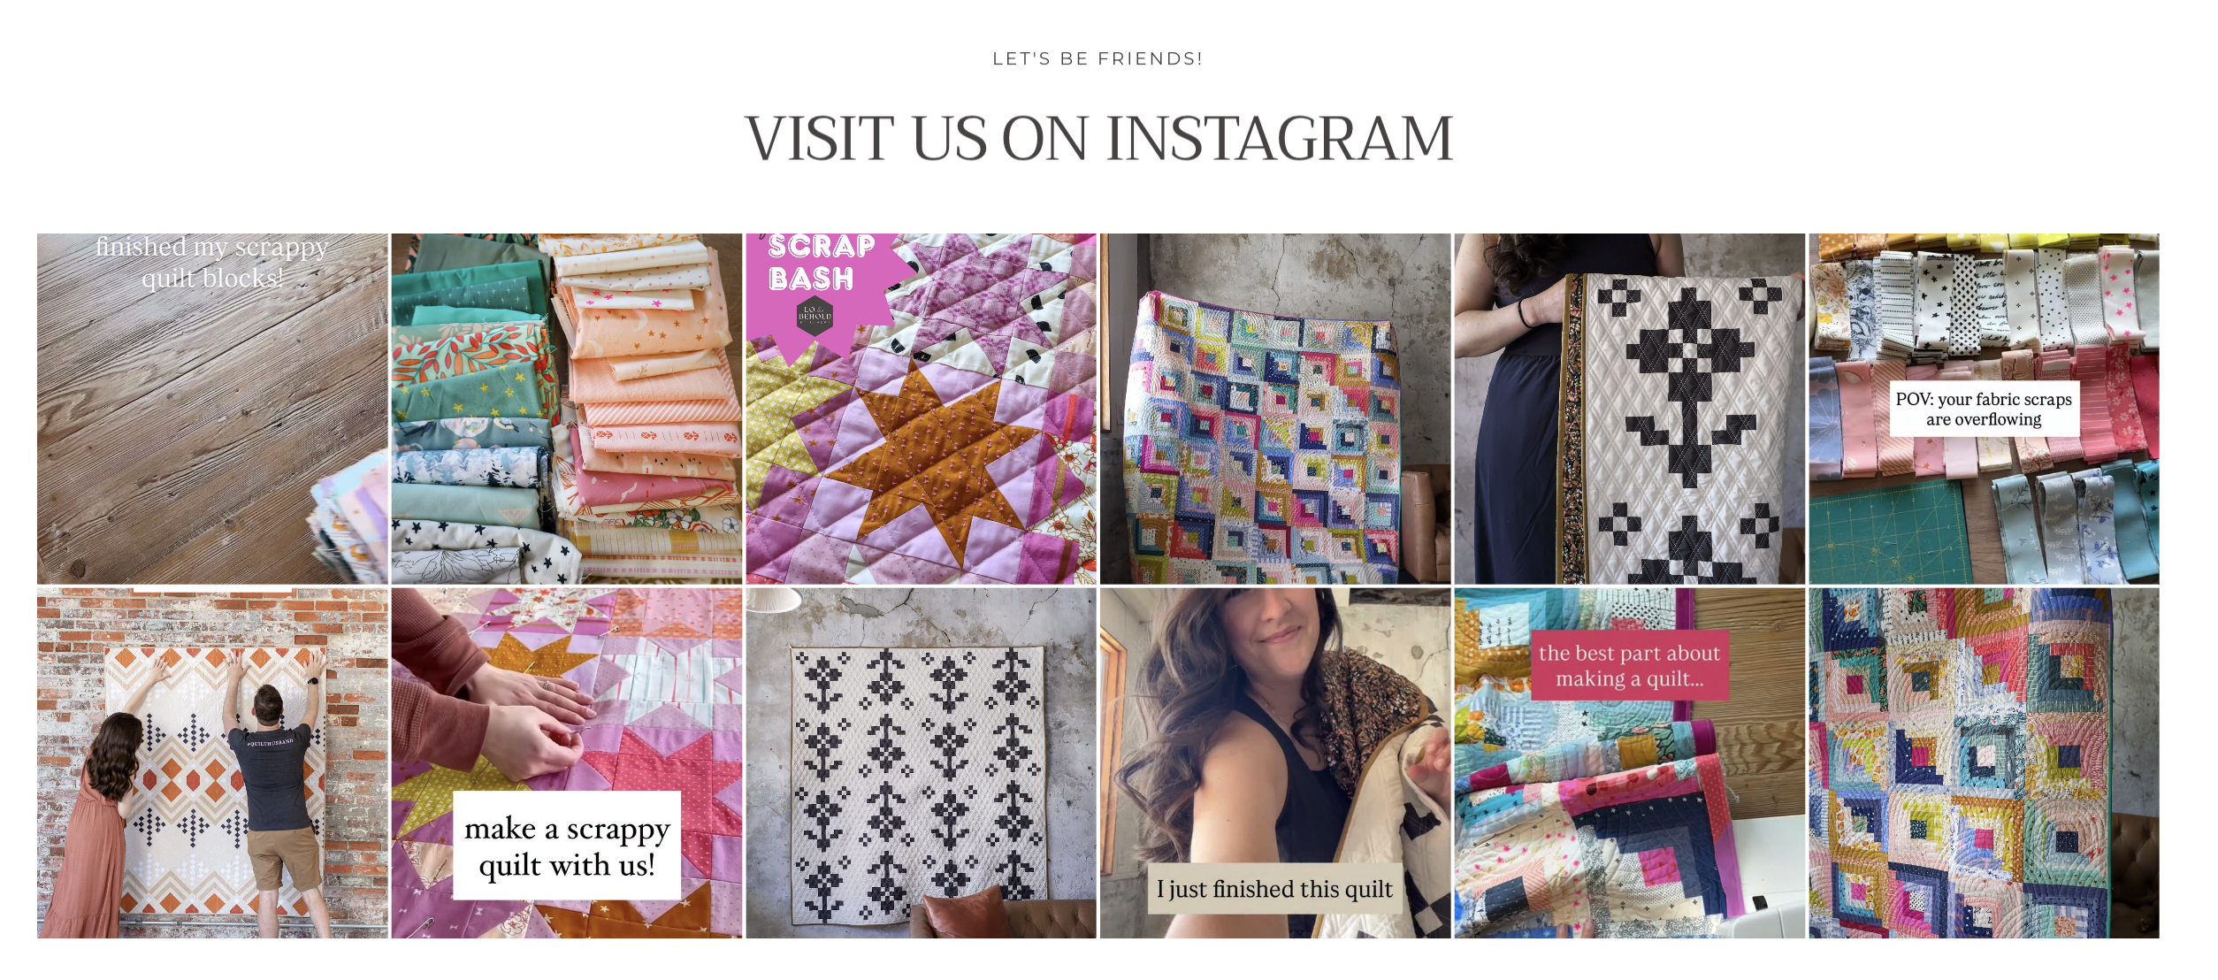
        - Add in email for any inquiries

Custom Request:
- Under #3 - update to: ‘Let us know if the quilt is for a special occasion / event / milestone’
- Add jpeg images option?
- Under ‘What happens next:?’ Update to “What to expect next”
- +1)NiNi-Q will follow up to discuss request in detail (timing, availability, design)
- 2) Customer will be provided document of proposed design, size, color etc.
- 3) Once design is established and approved (via email sign off), a non-refundable 50% deposit will be required. The balance will be due prior to shipmen

Bottom of Page:

- Add ‘Pattern Corrections’
      - Reference: https://quilterscandy.com/pattern-corrections
- Terms & Conditions
- Refund Policy

- Contact

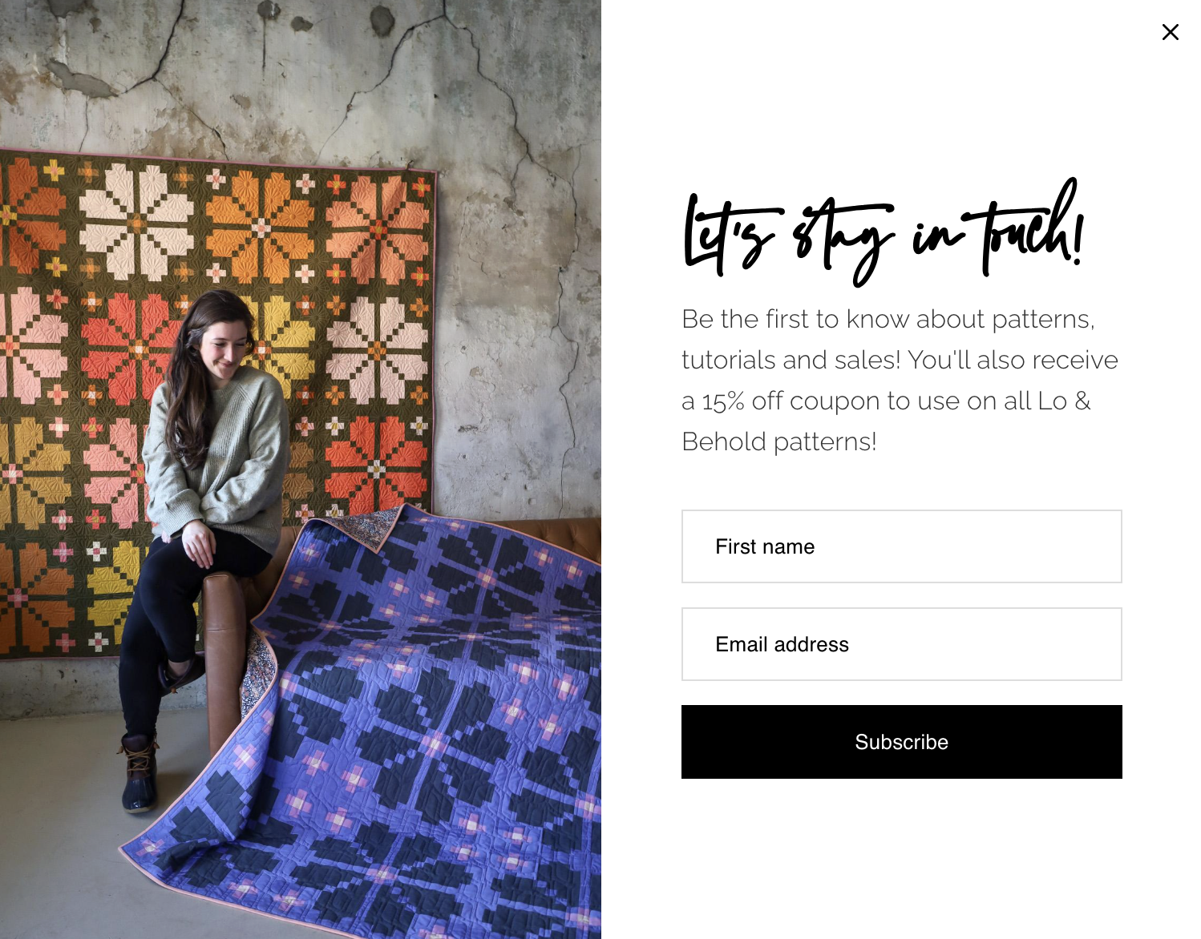
Can we add a pop up to website like below to give option to email/subscribe?

8/3/26 - quilts to sell updates

Cathedral Window
-Baby Quilt
-Material - 100% cotton
-36” x 36”
-$300
A modern take on the traditional Cathedral Window, mixing soft florals and subtle prints with navy framing. Intricate, dimensional, and made to be noticed.

Black and White Window
-Throw Quilt
-Material - 100% cotton
-43” x 57”
-$300
A graphic mix of black, white, and soft gray gives this quilt a clean, modern feel. Delicate botanical details soften the bold geometric design.

Daisy & Diamond
-Throw Quilt
-Material - 100% cotton
-40” x 55”
-$300
Deep greens, warm cream, and small-scale prints come together in a bold geometric design. A cozy mix of traditional quilting and modern color.

Blue and Pink Floral
-Throw Quilt
-Material - 100% cotton
-43” x 56”
-$175*
*Specially priced due to slight color transfer from the navy fabric onto some areas of the white. This cosmetic variation does not affect the craftsmanship, comfort, or functionality of the quilt.

Soft pink florals meet rich navy in a sweet patchwork design. Feminine without feeling overly delicate, with plenty of texture from the quilting.

Starry Night
-Baby Quilt
-Material - Top: 100% cotton, Backing: 100% Polyester Cuddle Plush
-40” x 46”
-$225
Tiny, unique burgundy stars scattered across a vintage inspired floral background create a simple, understated design. A quiet quilt with just the right amount of character.

Harvest Star - Vintage
-Baby Quilt
-Material - Top: 100% cotton + vintage floral print, Backing: 100% Polyester Cuddle Plush
-39” x 39”
-$225
A rich mix of florals, burgundy, mustard, and warm earthy tones creates a quilt that feels collected over time. Vintage floral fabric paired with solids to give a cozy and comfort look.

Harvest Star - Modern
-Baby Quilt
-Material - 100% cotton
-39” x 39”
Oversized stars in rust, blush, mustard, and soft floral prints give this quilt a warm, modern feel. Made for cozy fall days, but beautiful year-round.
-$225

Watercolor Floral Gauze -
-Twin Quilt
-Material - 100% gauze
-50” x 40”
-$200
-Hand stitched diamond pattern quilting
Bright watercolor-style florals scatter across a soft white background for a light, artistic feel with hand stitched diamond pattern top quilting

Starlet Quilt
Baby Quilt
-Material - 100% cotton + vintage fabric ditsy print*
*Crafted with vintage fabric. Natural variations in color, fading, and slight discoloration are part of its unique character and look
-44” x 44”
-$200
A soft, scrappy mix of florals and warm pastels comes together in playful star-inspired patchwork baby quilt. Light, charming, and full of little details to discover.

Ombré Waves
-Baby Quilt
-Material - Top: 100% cotton, Backing: 100% Polyester Cuddle Plush
-37” x 46”
-$225
A calming gradient moves from deep navy and ocean blue into soft aqua, gray, and cream wave like baby quilt. The flowing quilted texture gives it an easy, water-inspired feel.

Stripes & Ladder
-Baby Quilt
-40” x 40”
-$110*
*Specially priced due to slight color transfer from the navy fabric onto some areas of the white. This cosmetic variation does not affect the craftsmanship, comfort, or functionality of the quilt.
Clean geometric lines in rust, blush, green, and warm neutrals give this quilt a playful modern look. Simple shapes and unexpected color make it easy to style anywhere.

Comic Strip
-Material - 100% cotton
-36” x 40”
-$225
Tiny vintage-inspired comic prints peek through a crisp, neutral grid. Playful up close and surprisingly simple from afar.

Vintage Lace*
Baby Quilt
-Material - Top: 100% cotton, Backing: 100% Polyester Cuddle Plush
-46” x 45”
-$300
A playful mix of pink, blue, purple, and gray creates an energetic patchwork of tiny triangles. Scrappy, colorful, and perfectly imperfect.
*Available as a set with the King Size version for $700.

Vintage Lace*
-King Quilt
-Material - 100% cotton
-108” x 108”
-$600
-*Available as a set with the Baby Size version for $700.
Utilizing same prints from the baby version, but contrasted with white background compared to the gray.

I STILL OWE:

FREE DOCUMENT
VERBIAGE OF WEBSITE

SENT PART 3:
DESCRIPTION OF IMAGES
INSTAGRAM PHOTOS
PIC OF ME
RETURN POLICY
PATTERN CORRECTION PAGE
TERMS AND CONDITIONS
PRIVACY POLICY

